|  |
| --- |
| , RD Dep. |
| **Oracle SQL for Aggregation in Data Warehouses** |

|  |  |  |  |  |  |
| --- | --- | --- | --- | --- | --- |
| REVISION HISTORY | | | | | |
| Ver. | Description of Change | Author | Date | Approved | |
| Name | Effective Date |
| 1.0 | Initial Version | Olga Hilko | 14-Nov-2017 |  |  |
|  |  |  |  |  |  |

Contents

Task 1 3

Task 2 и 3 4

# Task 1

Собственно из-за отсутствия доступа к схеме делала на данных, которые нашла.

Пример данных CTE, которые я использовала в качестве источника (данные о билетах из страны в страну с указанием данных пассажира и цены билета).

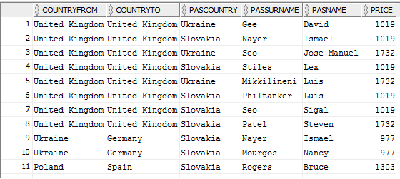

Подсчет итогов проводился для пассажиров из Украины и Словакии (по ним больше всего данных) с дополнительными условиями countryTo in ('Spain','Germany') и countryFrom in ('Spain','Germany', 'United Kingdom').

with CTE as (select

SUBSTR(afrom.ALOCATION,INSTR(afrom.ALOCATION, ',', -1)+2) countryFrom ,

SUBSTR(ato.ALOCATION,INSTR(ato.ALOCATION, ',', -1)+2) countryTo,

p.PASCOUNTY pasCountry, p.passurname, p.PASNAME, t.TICKET_PRICE price

FROM

passenger p left join TICKETS t on t.PASID = p.PASID

left join flight f on f.FCODE=t.FCODE

left join AIRPORT afrom on f.AIRPORTFROM=afrom.IATA_CODE

left join AIRPORT ato on f.AIRPORTTO=ato.IATA_CODE

where p.PASCOUNTY in ('Slovakia','Ukraine'))

SELECT nvl(DECODE(grouping_id(pasCountry), 0, pasCountry, 'GRAND TOTAL'),' ') AS pas_Country,

nvl(DECODE(grouping_id(pasCountry, countryFrom), 1, 'TOTAL by countryFrom', countryFrom), ' ') AS country_From,

nvl(DECODE(grouping_id(pasCountry, countryFrom, countryTo), 1, countryFrom || ' TOTAL(by countryTo)', countryTo), ' ') AS country_To,

count(*) times_count, min(price) min_price, max(price) maõ_price, sum(price) sum_price

from CTE

WHERE countryTo in ('Spain','Germany') and countryFrom in ('Spain','Germany', 'United Kingdom')

GROUP BY ROLLUP (pasCountry, countryFrom, countryTo) ;

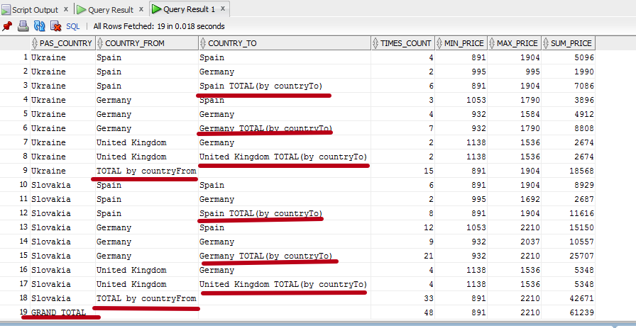

# Task 2 и 3

Так как в 3-м задании нужно сделать свой PIVOT, а задание у меня в принципе свое из-за не поднимающейся дома базы

with CTE as (select

SUBSTR(afrom.ALOCATION,INSTR(afrom.ALOCATION, ',', -1)+2) countryFrom ,

SUBSTR(ato.ALOCATION,INSTR(ato.ALOCATION, ',', -1)+2) countryTo,

p.PASCOUNTY pasCountry, p.passurname, p.PASNAME, t.TICKET_PRICE price

FROM

passenger p left join TICKETS t on t.PASID = p.PASID

left join flight f on f.FCODE=t.FCODE

left join AIRPORT afrom on f.AIRPORTFROM=afrom.IATA_CODE

left join AIRPORT ato on f.AIRPORTTO=ato.IATA_CODE

where p.PASCOUNTY in ('Slovakia','Ukraine'))

/*SELECT NVL(pasCountry, 'TOTAL'), --countryFrom,countryTo,

SUM(Spain), SUM(Germany), SUM(Spain)+SUM(Germany) AS Country_SUM

FROM (*/

SELECT NVL(pasCountry, 'TOTAL'),

nvl(DECODE(grouping_id(pasCountry, countryFrom), 1, 'SUBTOTAL', countryFrom), ' ') AS country_From,

--NVL(countryFrom, 'SUBTOTAL') countryFrom ,

SUM(Spain), SUM(Germany), SUM(Spain)+SUM(Germany) AS Country_SUM

FROM (

SELECT pasCountry, countryFrom, countryTo, price

FROM CTE

WHERE countryTo in ('Spain','Germany') and countryFrom in ('Spain','Germany', 'United Kingdom'))

PIVOT

(SUM(price)

FOR countryTo

IN('Spain' as Spain,'Germany' as Germany))

GROUP BY ROLLUP(pasCountry, countryFrom)

--ORDER BY 1,2

;

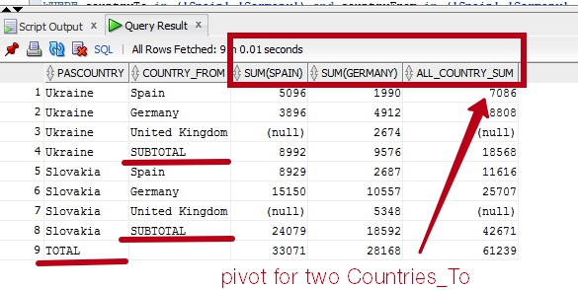

Аи теперь наведем лоск: обработаем null, объединим строки внутри subtotal с использованием grouping_id

with CTE as (select

SUBSTR(afrom.ALOCATION,INSTR(afrom.ALOCATION, ',', -1)+2) countryFrom ,

SUBSTR(ato.ALOCATION,INSTR(ato.ALOCATION, ',', -1)+2) countryTo,

p.PASCOUNTY pasCountry, p.passurname, p.PASNAME, t.TICKET_PRICE price

FROM

passenger p left join TICKETS t on t.PASID = p.PASID

left join flight f on f.FCODE=t.FCODE

left join AIRPORT afrom on f.AIRPORTFROM=afrom.IATA_CODE

left join AIRPORT ato on f.AIRPORTTO=ato.IATA_CODE

where p.PASCOUNTY in ('Slovakia','Ukraine'))

SELECT case when pasCountry is null then 'TOTAL'

when grouping_id(pasCountry, countryFrom)= 1 then pasCountry||' ' || 'SUBTOTAL'

else pasCountry end pasCountry,

nvl(DECODE(grouping_id(pasCountry, countryFrom), 1, ' ', countryFrom), ' ') AS country_From,

nvl(SUM(Spain),0) as Spain, nvl(SUM(Germany),0) as Germany, nvl(SUM(Spain),0)+nvl(SUM(Germany),0) AS BOTH_COUNTRIES_SUM

FROM (

SELECT pasCountry, countryFrom, countryTo, price

FROM CTE

WHERE countryTo in ('Spain','Germany') and countryFrom in ('Spain','Germany', 'United Kingdom'))

PIVOT

(SUM(price)

FOR countryTo

IN('Spain' as Spain,'Germany' as Germany))

GROUP BY ROLLUP(pasCountry, countryFrom);

